
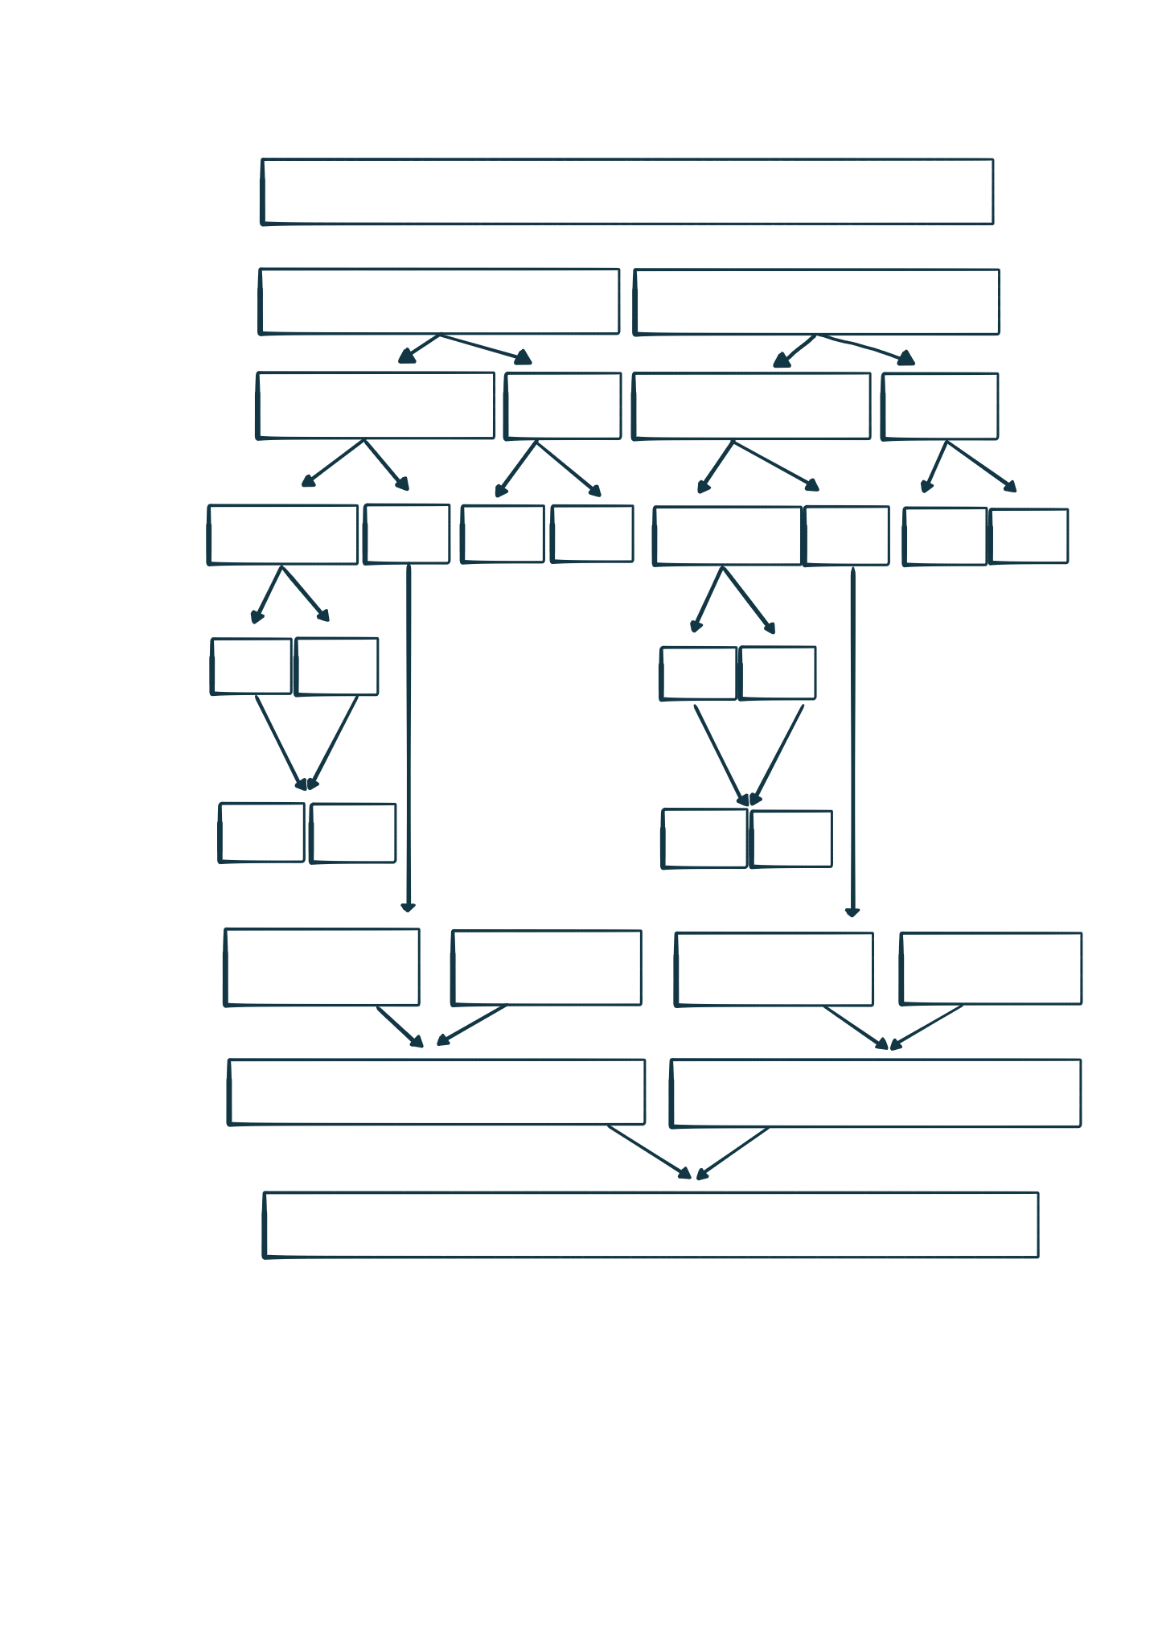
17, 5, 23, 8, 14, 3, 11, 20, 6, 9
17, 5, 23, 8, 14
3, 11, 20, 6, 9
17, 5, 23
8, 14
3, 11, 20
6, 9
17, 5,
23
8
14
3, 11
20
6
9
17
5
11
3
5
17
11
3
5, 17, 23
8, 14
3, 11, 20
6, 9
5, 8, 14, 17, 23
3, 6, 9, 11, 20
3, 5, 6, 8, 9, 11, 14, 17, 20, 23
MERGE DIAGRAM

